

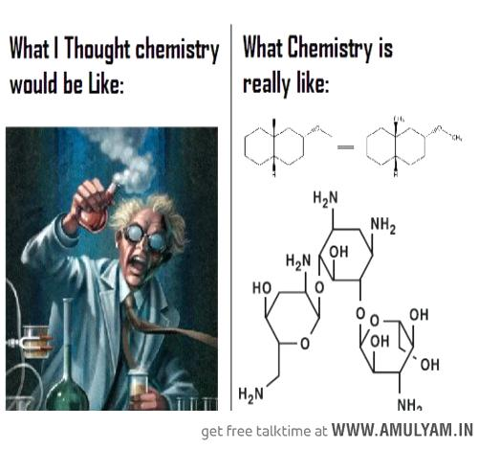
Chemical Synthesis


(Wanelo 2016)
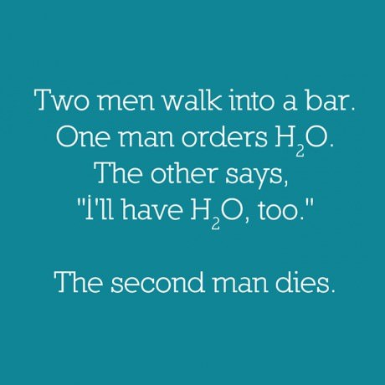
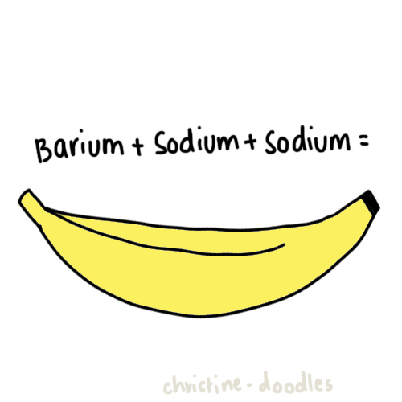
(Vignesh n.d.)

(Onsdag 2015)
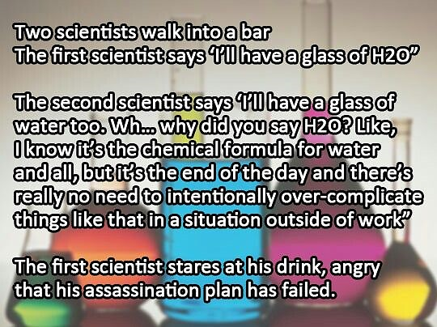
(Sptcard.com 2016)

(Nizalowski n.d.)

Week | topic | unit content | assessment
24 – 29 | Chemical Synthesis | - Scientific knowledge can be used to design alternative chemical synthesis pathways, taking into account sustainability, local resources, economics and environmental impacts (green chemistry), including the production of ethanol and biodiesel.  - chemical synthesis to form products with specific properties may require the construction of reaction sequences with more than one chemical reaction and involves the selection of particular reagents and reaction conditions in order to optimise the rate and yield of the product  - quantities of products in a chemical synthesis reaction can be calculated by comparing stoichiometric quantities with actual quantities and by determining the limiting reagent  - the percentage yield of a chemical synthesis reaction can be calculated by comparing theoretical versus actual product quantities  - reagents and reaction conditions are chosen to optimise yield and rate for chemical synthesis processes, including in the production of ammonia (Haber process), sulfuric acid (Contact process) and biodiesel (base-catalysed and lipase-catalysed methods)  - enzymes are protein molecules which are biological catalysts and can be used on an industrial scale to produce chemicals that would otherwise require high pressure or temperature conditions to achieve an economically viable rate, including fermentation to produce ethanol versus hydrolysis of ethene  - chemical synthesis processes may involve the construction of reaction sequences with more than one chemical reaction, including the hydrolysis of ethene to form ethanol and the subsequent reaction of ethanol with acetic (ethanoic) acid to produce ethyl ethanoate  - the base hydrolysis (saponification) of fats (triglycerides) produces glycerol and the salt of a long chain fatty acid (soap)  - the structure of soaps contains a non-polar hydrocarbon chain and a carboxylate group; the structure of the anionic detergents derived from dodecylbenzene contains a non-polar hydrocarbon chain and a sulfonate group  - the cleaning action of soaps and detergents can be explained in terms of their non-polar hydrocarbon chain and charged group; the properties of soaps and detergents in hard water can be explained in terms of the solubilities of their calcium salts  - industry produces a vast range of plastics, including addition polymers (for example, polyethene and polytetrafluoroethene) and condensation polymers (for example, nylon and polyethylene terephthalate [PET]) which have different properties and uses  - the varied structures of different plastics due to characteristics, including cross-linking, chain length, and intermolecular forces leads to a range of distinct properties and consequent uses (for example, the different structures, properties and related uses for polyethene, polytetrafluoroethene, nylon and polyethylene terephthalate [PET]) | Extended Response 2  Test 5

Green chemistry are the principles developed by chemists and the chemical industry to enact a more sustainable industry. The commonly accepted principles of green chemistry include:
- Prevention – preventing waste is easier than cleaning it up.
- Atom economy – maximise the incorporation of all materials used during the process into the final product.
- Less hazardous chemical synthesis – generating little or no toxic products or by-products.
- Designing safer chemicals – chemical products designed to affect their desired function only.
- Safer solvents and auxiliaries – these should be made unnecessary wherever possible and innocuous.
- Design for energy efficiency – energy requirements should be minimised.
- Use of renewable feedstocks – raw materials should be renewable.
- Reduce derivatives – keep process as simple as possible.
- Catalysis – as selective as possible (preferable to stoichiometric reagents).
- Design for degradation – products breakdown safely at the end of their use.
- Real-time analysis for pollution prevention – minimise pollution and hazardous substances.
- Inherently safer chemistry for accident prevention – process chosen to minimize the potential for accidents.

In general, chemical processes are optimised to maximise the yield (amount of product) and rate. This will often require the application of collision theory, equilibria chemistry and catalysts (including enzymes which can eliminate potential side reactions).

Biofuels
Biofuels (such as bioethanol and biodiesel) are produced from biomass.
- They are renewable resources
- Natural products with limited health or environmental impact
- CO₂ production is balanced (CO₂ absorbed by plants is released when biomass is used)
- Biofuels produce less particulate emissions
Ethanol
Two methods for producing ethanol
- Synthesis by Fermentation (Greener Method)
- Accounts for 93% of world ethanol production
- Relies on yeast that produce enzymes which catalyse plant (e.g. corn ,wheat, sugar cane, potatoes, etc) carbohydrates (e.g. sugar, starch, etc) into ethanol
- Most ethanol produced is used for motor fuel or a fuel blend.
- Two major reactions are hydrolysis of sucrose to glucose and fructose (catalysed by the yeast enzyme invertase or sucrase) and fermentation of glucose/fructose mixture to produce ethanol and carbon dioxide (catalysed by the yeast enzyme zymase).

Hydrolysis of Sucrose:
C₁₂H₂₂O_{11(aq)} + H₂O_{(l)} 2C₆H₁₂O_{6(aq)}
Fermentation:
C₆H₁₂O_{6(aq)} 2C₂H₅OH_{(aq)} + 2CO_{2(g)}
Overall:
C₁₂H₂₂O_{11(aq)} + H₂O_{(l)} 4C₂H₅OH_{(aq)} + 4CO_{2(g)}

- Specific conditions chosen depends on nature of yeast chosen and feedstock used.
- Enzymes are protein molecules which are biological catalysts.
  - They speed up reaction rates by producing an alternate reaction pathway that has a lower activation energy (hence more particles have sufficient kinetic energy to meet the new required activation energy).
  - Most tend to be very specific (enzyme specificity) in the reactions they catalyse.
  - Their complex structure and shape allows a reactant molecule (substrate) to fit onto a specific active site on the enzyme through weak intermolecular forces.
  - Whilst in position, bonds are more easily rearranged, producing new products.
  - Typically referred to as the lock and key model.
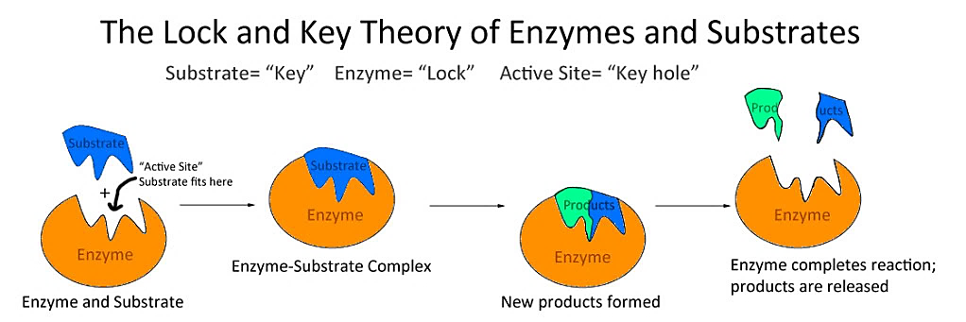

(Wikianswers n.d.)
  - Due to enzyme specificity, there is less chance of side reactions and unwanted by-products being formed in industrial processes.
  - Enzymes are specific to both temperature and pH. These conditions can affect conformation and effectiveness. They are said to be denatured (structure and shape are altered) if pH and temperature conditions are not correct.
  - When a catalyst is present reaction rate increases to a point if the concentration of a reactant is increased (due to limited active sites being available).

- As fermentation is an exothermic process, cooling is required to prevent denaturing of the enzymes involved. A slightly acidic pH (3 – 5) is typically chosen.
- During the initial phase of fermentation, yeast grows and reproduces rapidly. It respires aerobically and quickly uses up all oxygen available. If the reaction vessel is sealed, this then causes anaerobic respiration to take place (whereby glucose is converted to ethanol).
- Nutrients (e.g. diammonium hydrogenphosphate) may also be added to promote the growth and reproduction of the yeast.
- At around 8 – 14% ethanol concentration, the yeast are killed off by alcohol poisoning. They are removed and the mixture distilled to produce 95% ethanol.

- Synthesis from Ethene
- Quicker method using acid catalysed addition reaction of water and ethene (can be part of petroleum production and refining process).
- Involves passing steam and ethene through a catalyst bed made of silica particles coated with pure phosphoric acid as they catalyst.

CH₂=CH_{2(g)} + H₂O_{(g)} ⇌ CH₃CH₂OH_{(g)} ΔH = ‒45 kJ

- Temperature of around 300 ºC and pressure of 6 – 7 MPa used
- At a high temperature, reaction rate is increased because the average kinetic energy of the reactant particles is increased. This means a greater proportion of reactant particles now have sufficient kinetic energy to meet the activation energy require to react. This increases the frequency of successful collisions. The velocity of the particles also increases which results in a greater rate of collisions and so increases (to a lesser degree) the reaction rate.
- At an increased temperature, the rate of the forward and reverse reactions increase. The rate of the endothermic reaction is increased more than the exothermic reaction which in this case, the endothermic reaction is the reverse reaction. This means a lesser yield of ethanol would be produced at a higher temperature (i.e. equilibrium will shift left). As such a compromise of 300 ºC is used to ensure a sufficient yield at an acceptable reaction rate.
- At a higher pressure, the reaction rate increases due to an increased frequency of collisions (due to less distance between particles) and the yield also increases due to a greater number of particles being present on the reactant side in the forward reaction (i.e. equilibrium shifts to the right).
- Catalyst also increases the reaction rate but has no effect on yield.
- Molar ratio of ethene to water used is 1:0.6 as at 1:1 steam dilutes and washes away H₃PO₄.
- Under these conditions 5% conversion occurs so ethanol is separated and the mixture repeatedly passed over the catalyst so that an overall yield of 95% is achieved.
Biodiesel
- Contains methyl or ethyl esters
- Produced almost solely through base catalysed transesterification of triglycerides found in natural fats and oils.

(Good biodiesel product)
(Bad feedstock)
(R tends to be between 8 – 21 carbon atoms)
(Good feedstock)
- Feedstock is filtered and treated to remove any water and free fatty acids.
  - Free fatty acids can produce soap (carboxylate ion) by reacting with base. This soap then emulsifies with biodiesel making it difficult to extract.
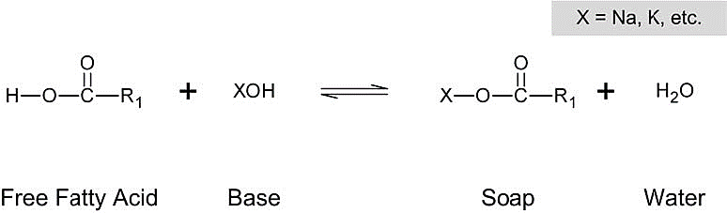

  - If there are significant free fatty acids present in the feedstock, they must be treated with methanol and H₂SO₄ catalyst to convert them to methyl esters.

(fatty acid - bad) (methyl ester – biodiesel - good)

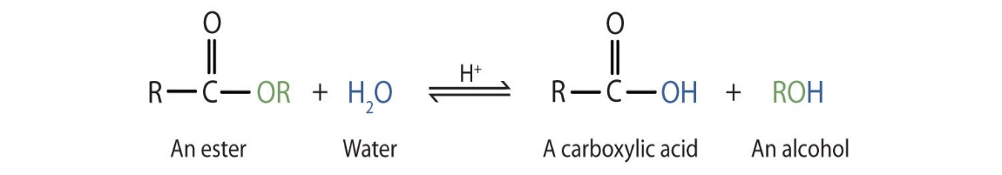
  - Water can also react with biodiesel (a long chain ester) to reverse the esterification reaction to produce alcohol and carboxylic acid.

(NA, 2019)

- Once water and free fatty acids are removed the oil can then undergo transesterification to produce biodiesel through reacting the triglyceride with methanol in a sealed vessel (to prevent loss of methanol). Methanol is added in a large excess to increase the equilibrium yield of biodiesel.
- A NaOH or KOH catalyst is used to increase the reaction rate as is a moderate temperature (60 ºC).

(triglyceride) (methyl ester – biodiesel) (glycerol)

- The biodiesel and glycerol form two separate layers. The biodiesel (top layer – less dense) is washed with warm water and dried ready for use.

- A greener method involves using lipases (a group of enzymes) in place of the base catalyst.

- Advantages of using lipases
  - Milder temperature , 40-45 ⁰C, (less energy required) and pH conditions.
  - Can tolerate feedstocks high in free fatty acids (no need to pre-treat).
  - Can simultaneously catalyse transesterification and esterification of free fatty acids.
  - No side reactions.

- Impediments to using lipases
  - Slower reaction rate (higher concentration needed).
  - Expensive.
  - Recovery from final mixture is difficult (may be overcome by binding lipase onto a solid particle surface).
  - High concentration of alcohol inhibits its use. This is a problem because methanol is one of the reactants and glycerol is one of the products.
Haber Process
- Produces ammonia on an industrial scale (which can be used to produce fertilisers, polymers, explosives and cleaning agents).
- Reaction given by: N_{2(g)} + 3H_{2(g)} ⇌ 2NH_{3(g)} ΔH = ‒92 kJ

Condition | Effect on Rate | Explanation | Effect on Yield | Explanation | Compromise
Increase temperature | Increased | Increased average kinetic energy means a greater proportion of particles have sufficient energy to meet activation energy required (and increased velocity means more collisions) | Decreased | Both forward and reverse reactions increase however endothermic reverse reaction is increased more (producing more reactants) | Moderate temperature ensures acceptable yield at reasonable rate  350 – 550 ºC
Increase pressure | Increased | Increased pressure (increased concentration) reduces spaces between particles so frequency of collisions increases | Increased | According to Le Chatelier’s, the equilibrium will shift to oppose the increase in pressure. As such, the equilibrium shifts to the right as there are less particles on the product side. | High pressure used (but limited by safety issues and cost)  15 – 35 MPa
Add catalyst | Increased | Provides an alternate reaction pathway that has a lower activation energy so a greater proportion of particles have sufficient energy to meet activation energy required | No effect | Increase rate of forward and reverse reaction rates equally | Catalysts used to increase reaction rate  FeFe₂O₄/MgO  /Al₂O₃/SiO₂ catalyst

- The ammonia produced (with a yield of 15 – 30%) is condensed so that the ammonia is liquefied and can be drained off whilst the remaining N_{2(g)} and H_{2(g)} can be recycled. How can the NH_{3(g)} be liquefied and the N_{2(g)} and H_{2(g)} remain gaseous?
NH_{3(g)} possesses the stronger intermolecular forces of hydrogen bonding and dispersion forces whilst N_{2(g)} and H_{2(g)} possess only dispersion forces. As such, NH_{3(g)} has a higher boiling point and will liquefy first.
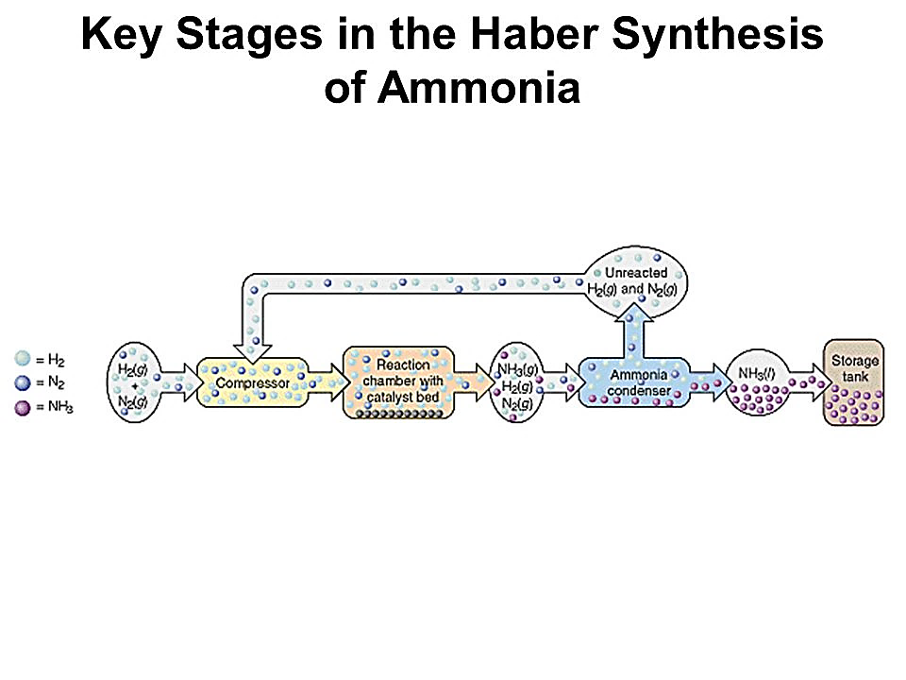

(Reder n.d.)
- N_{2(g)} is obtained from the atmosphere but H_{2(g)} is produced through two reactions:
(steam reforming) CH_{4(g)} + H₂O_{(g)} ⇌ CO_{(g)} + 3H_{2(g)} ∆H = +206 kJ
(‘shift’ reaction) CO_{(g)} + H₂O_{(g)} ⇌ H_{2(g)} + CO_{2(g)} ∆H = −41 kJ
Contact Process
- Produces sulfuric acid on an industrial scale (which can be used to produce fertilisers, detergents, other acids, polymers, explosives and used in metal extraction).
- First stage: Production of sulfur dioxide
S_{(l)} + O_{2(g)} → SO_{2(g)} ΔH = ‒297 kJ

Some sulfuric acid plants are integrated into metal sulfide smelting plants to use the waste SO_{2(g)} produced rather than burning S_{(l)}.

- Second stage: Conversion of sulfur dioxide to sulfur trioxide

2SO_{2(g)} + O_{2(g)} ⇌ 2SO_{3(g)} ΔH = ‒198 kJ

Condition | Effect on Rate | Explanation | Effect on Yield | Explanation | Compromise
Increase temperature | Increased | Increased average kinetic energy means a greater proportion of particles have sufficient energy to meet activation energy required (and increased velocity means increased rate of collisions) | Decreased | Both forward and reverse reactions increase however endothermic reverse reaction is increased more (producing more reactants) | Moderate temperature ensures acceptable yield at reasonable rate  450 ºC
Increase pressure | Increased | Increased pressure (increased concentration) reduces spaces between particles so frequency of collisions increases | Increased | According to Le Chatelier’s, the equilibrium will shift to oppose the increase in pressure. As such, the equilibrium shifts to the right as there are less particles on the product side. | Normal pressure used due to excessive cost  100 – 200 kPa
Add catalyst | Increased | Provides an alternate reaction pathway that has a lower activation energy so a greater proportion of particles have sufficient energy to meet activation energy required | No effect | Increases rates of forward and reverse reactions equally | Catalysts used to increase reaction rate  V₂O₅ Catalyst
Remove product | No change | No change | Increased | As partial pressure of SO_{3(g)} is reduced, rate of reverse reaction decreases relative to forward reaction. This increases the production of SO_{3(g)}. | Product removed
- Stage three: Conversion of sulfur trioxide to sulfuric acid

(oleum production) H₂SO_{4(l)} + SO_{3(g)} → H₂S₂O_{7(l)}
(water added) H₂S₂O_{7 (l)} + H₂O_{(l)} → 2H₂SO_{4(l)}
(overall) H₂O_{(l)} + SO_{3(g)} → H₂SO_{4(l)}

- SO_{3(g)} is not added directly to water to produce H₂SO_{4(l)} as this is a highly exothermic reaction and would produce a highly corrosive mist of concentrated H₂SO_{4(l)}.

Manufacture of Ethyl Ethanoate
- Ethyl ethanoate is a very useful, non-toxic solvent.
- Produced through the esterification of ethanoic acid with ethanol with a sulfuric acid catalyst (Fisher esterification reaction).

- Excess of the cheaper ethanol is used to maximise the yield. The ethanol can be produced through the acid catalysed addition reaction of ethene and water.
- The reaction produces a yield of 65% at a temperature of 25 ºC.
- Yield is increased up to 95% by continually removing the products.
Quantities in Chemical Synthesis
- In general, stoichiometric quantities are used in synthesising specific products (although on an industrial scale, the cheaper reactant is often in excess).
- Where equilibrium reactions are involved, yields of 100% may not be economically viable. Nevertheless, companies will always try to maximise yields in order to increase profit margins. Yields can be affected by:
  - Loss of reagent through side reactions
  - Loss of product
  - Incomplete reaction
  - Presence of impurities

- % yield can be calculated using the formula:

Example: Calculate the percentage yield of sulfuric acid produced through the Contact process if 1.089 ×10³ L of H₂SO₄ is produced when 3.253 ×10⁵ g of sulfur is reacted with 3.408 ×10⁵ g of oxygen gas (H₂SO₄ has a density of 1.840 g mL⁻¹).

S_{(l)} + O_{2(g)} → SO_{2(g)}
2SO_{2(g)} + O_{2(g)} ⇌ 2SO_{3(g)}
H₂SO_{4(l)} + SO_{3(g)} → H₂S₂O_{7(l)}
H₂S₂O_{7(l)} + H₂O_{(l)} → 2H₂SO_{4(l)}

n(S) = (3.253 ×10⁵)/32.07 n(O₂) = (3.408 ×10⁵)/32.00
= 10143.4 mol = 10650 mol
Compare n(S) = 10143.4/1 Compare n(O₂) = 10650/1
= 10143.4 mol = 10650 mol
S is limiting reagent as it is present less on a mole to mole basis.

n(SO₂) = n(S) = 10143.4 mol
n(SO₃) = n(SO₂) = 10143.4 mol
n(H₂S₂O₇) = n(SO₃) = 10143.4 mol
n(H₂SO₄) = 2 ×n(H₂S₂O₇) = 20286.9 mol

m(H₂SO₄) = (20286.9)×98.086 = 1989858.2 g (theoretical yield)
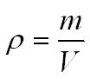
Actual yield = (1.089 ×10³) × (1 ×10³) × (1.840) = 2003760 g
% yield = (2003760/1989858.2) ×100
∴ = 100.7 %
Soaps and Detergents
- Heating an ester with a strong base causes its hydrolysis.

- Ester hydrolysis is used to produce soap (process is called saponification).

(triester) soap (sodium stearate) (glycerol)
- Soap is able to clean because of its structure. It possesses a long, non-polar hydrocarbon tail and a highly charged ionic (carboxylate ion) head.

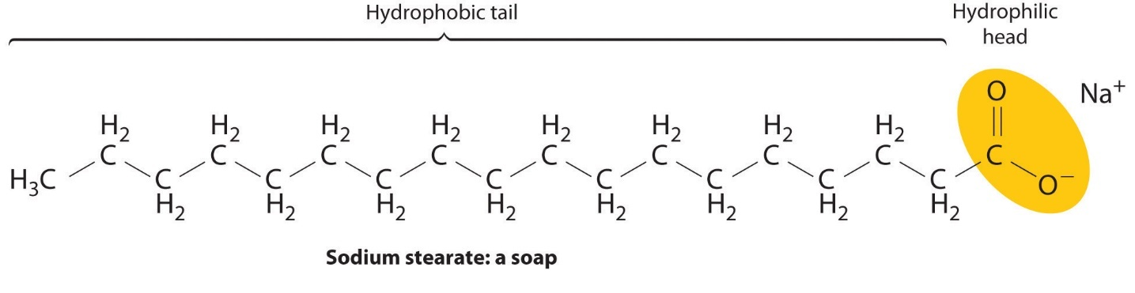

(Konold n.d.)
- Soap molecules (or surfactant ions) attach to grease and dirt through dispersion forces between the non-polar (hydrophobic) tail and the non-polar grease. The anionic (hydrophilic) head is attracted to water molecules (through ion-dipole interactions). As the soap pulls the grease away from the (for example) fabric, they form spherical structures called micelles.

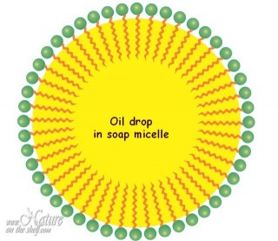

(Natureontheshelf 2016)
- Hot water and agitation further improve the cleaning action of soap.
- Hard water (water with a relatively high concentration of calcium and/or magnesium ions) prevents the use of soaps as cleaning agents as the surfactant ions form a precipitate known as scum.
Ca²⁺_{(aq)} + 2CH₃(CH₂)₁₆COO⁻_{(aq)} → Ca(CH₃(CH₂)₁₆COO)_{2(s)}
- Detergents (synthetic soaps) are similar to soaps but they do not form scum in hard water. They can be produced more cheaply than soaps through the reaction of sulfuric acid with petroleum products. They are also better cleaners than soaps.
- Sodium dodecylbenzenesulfonate is a typical anionic detergent.
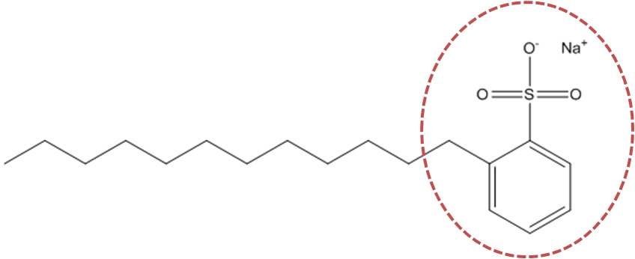

(Reckitt Benckiser n.d.)

- Enzymes (such as lipase and protease) can be used to improve the cleaning effectiveness of soaps and detergents by catalysing the breakdown of the fats and proteins into smaller molecules which are then more soluble with the soap or detergent.

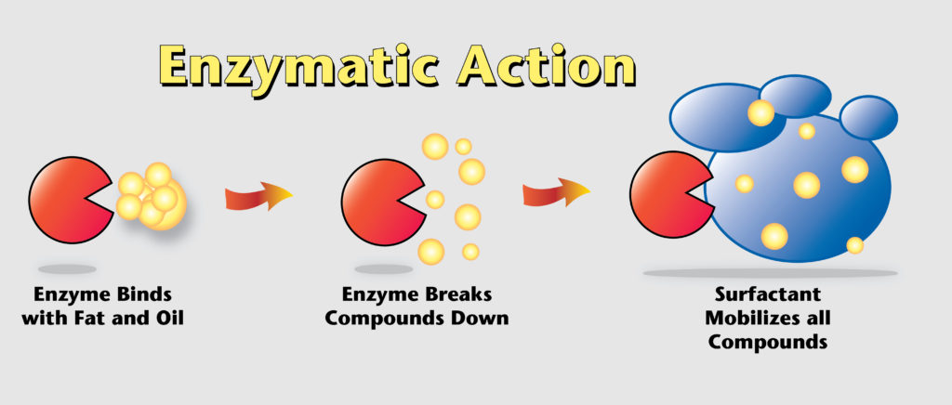

(Multi-Clean 2016)
Properties and Uses of Polymers
- Polyethene (polyethylene) – can be LDPE: has a relatively low melting point, is soft, flexible and insulating, Used for packing film, tubing, bottles, electrical cable insulation and toys. HDPE has a higher melting point, is harder and more rigid. It is used for chopping boards, pipes, toys and crates.

- Polytetrafluororethylene (PTFE) – higher strength of C‒F bonds give it a higher chemical resistance than polyethylene (even at higher temperatures). It is non-stick, has a high melting point and high electrical resistance. It is used in cooking pans, coatings on bearings and semi-permeable membranes in fuel cells.

- Polyethylene terephthalate (PET) – is a polyester made through the condensation reaction of benzene-1,4-dicarboxylic acid and ethane-1,2-diol. It can interact through dipole-dipole forces which makes it stronger than polyethylene. It is used to make fibres, solar cells, thermal blankets and plastic bottles.
- Nylon – is a polyamide made through the condensation polymerisation of hexanedioic acid and hexane-1,6-diamine (this is nylon 6,6. Nylon 6 is made using the one monomer, 6-aminohexanoic acid) . The ability of nylon to form hydrogen bonds between the lone pair of electrons on the oxygen in the carbonyl group and the hydrogen from the amine group greatly increases its tensile strength. It is used in clothing, fishing line, rope, carpet, parachutes, seat belts and tents.

Characteristics such as cross-linking (when multiple polymers bond together), chain length, branching and intermolecular forces present all affect the properties and, hence, uses, of particular polymers.

Crosslinking effectively makes many polymers into one giant polymer. This improves strength, chemical resistance and raises melting point. Usually, polymers are crosslinked once they have formed their shape as they cannot be remoulded once they are shaped (this means they are thermoset polymers…which makes them very hard to recycle. Thermoplastics are not crosslinked polymers and can be reshaped once moulded).

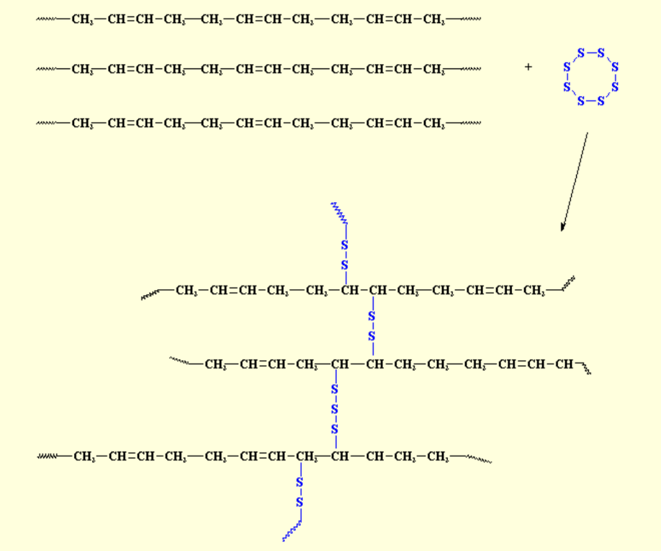
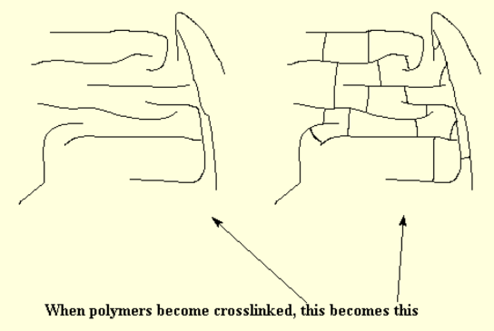

(Polymer Science Learning Centre 2003)

(Polymer Science Learning Centre 2003)

Vulcanised rubber is made by crosslinking rubber molecules with sulfur bridges (links).

In general:
- As chain length of polymers increases, the intermolecular forces increase and their strength, rigidity and melting/boiling points increase.

- As branching of polymers increases (ie move from high density to low density), the intermolecular forces decrease (due to being unable to come as close together as their unbranched counterparts) and their strength, rigidity and melting/boiling points decrease.

Bibliography
Konold, C. n.d. "Chem 1010." Education Portfolio. Accessed August 3, 2016. https://catherinekonold.wordpress.com/as-general-education/chem-1010/.
Multi-Clean. 2016. How to Remove Odors Using Bio-Enzymatic. June 30. Accessed September 2021. https://multi-clean.com/eliminate-odors-enzyme-cleaners/.
Natureontheshelf. 2016. "How Soap Works." Nature on The Shelf. Accessed August 3, 2016. http://www.natureontheshelf.com/soap-making/how-soap-works.html.
Nizalowski, I. n.d. "Explore Secret Stuff, Nerd Jokes and More!" Pinterest. Accessed August 3, 2016. https://au.pinterest.com/pin/328622104030498130/.
Onsdag. 2015. "Week 52." B and K Technologists. Accessed August 3, 2016. http://www.ksek.se/en-GB/student_-26268260.
Polymer Science Learning Centre. 2003. What Crosslinking is All About...And Why. Accessed September 2021. https://www.pslc.ws/macrog/xlink.htm.
Reckitt Benckiser. n.d. "Greasy Stains." Chemistry inYour Cupboard. Accessed August 3, 2016. http://www.rsc.org/learn-chemistry/resources/chemistry-in-your-cupboard/vanish/9.
Reder, C. n.d. "Chapter 6 Chemical Equilibrium." Slide Player. Accessed August 3, 2016. http://slideplayer.com/slide/4213696/.
Sptcard.com. 2016. "sptcard.com." Soda Pun Jokes. Accessed August 3, 2016. http://www.sptcard.com/soda/soda-pun-jokes.
Vignesh. n.d. "Chemistry Expectations." Amulyam. Accessed August 3, 2016. http://www.amulyam.in/funny-pics-chemistry-expectations-117084.
Wanelo. 2016. "Chemistry Puns." Wanelo. Accessed August 3, 2016. https://wanelo.com/shop/chemistry-puns.
Wikianswers. n.d. "What Do Enzymes and Substrates Look Like." Answers.com. Accessed August 3, 2016. http://www.answers.com/Q/Why_is_an_enzyme_called_lock_and_key_model?#slide=1.

